AWS Cloud Practitioner Notes

IAM Section
- Users: mapped to a physical user, has a password for AWS Console
- Groups: contains users only
- Policies: JSON document that outlines permissions for users or groups
- Roles: for EC2 instances or AWS services
- Security: MFA + Password Policy
- AWS CLI: manage your AWS services using the command-line
- AWS SDK: manage your AWS services using a programming language
- Access Keys: access AWS using the CLI or SDK
- Audit: IAM Credential Reports & IAM Access Advisor

EC2 Section
- EC2 Instance: AMI (OS) + Instance Size (CPU + RAM) + Storage + security groups + EC2 User Data
- Security Groups: Firewall attached to the EC2 instance
- EC2 User Data: Script launched at the first start of an instance
- SSH: start a terminal into our EC2 Instances (port 22)
- EC2 Instance Role: link to IAM roles
- Purchasing Options: On-Demand, Spot, Reserved (Standard + Convertible), Dedicated Host, Dedicated Instance

EC2 Instance Storage
- EBS volumes:
  - network drives attached to one EC2 instance at a time
  - Mapped to an Availability Zones
  - Can use EBS Snapshots for backups / transferring EBS volumes across AZ
- AMI: create ready-to-use EC2 instances with our customizations
- EC2 Image Builder: automatically build, test and distribute AMIs
- EC2 Instance Store:
  - High performance hardware disk attached to our EC2 instance
  - Lost if our instance is stopped / terminated
- EFS: network file system, can be attached to 100s of instances in a region
- EFS-IA: cost-optimized storage class for infrequent accessed files
- FSx for Windows: Network File System for Windows servers
- FSx for Lustre: High Performance Computing Linux file system

ELB & ASG
- High Availability vs Scalability (vertical and horizontal) vs Elasticity vs Agility in the Cloud
- Elastic Load Balancers (ELB)
  - Distribute traffic across backend EC2 instances, can be Multi-AZ
  - Supports health checks
  - 4 types: Classic (old), Application (HTTP – L7), Network (TCP – L4), Gateway (L3)
- Auto Scaling Groups (ASG)
  - Implement Elasticity for your application, across multiple AZ
  - Scale EC2 instances based on the demand on your system, replace unhealthy
  - Integrated with the ELB

Amazon S3
- Buckets vs Objects: global unique name, tied to a region
- S3 security: IAM policy, S3 Bucket Policy (public access), S3 Encryption
- S3 Websites: host a static website on Amazon S3
- S3 Versioning: multiple versions for files, prevent accidental deletes
- S3 Replication: same-region or cross-region, must enable versioning
- S3 Storage Classes: Standard, IA, 1Z-IA, Intelligent, Glacier (Instant, Flexible, Deep)
- Snow Family: import data onto S3 through a physical device, edge computing
- OpsHub: desktop application to manage Snow Family devices
- Storage Gateway: hybrid solution to extend on-premises storage to S3

Databases & Analytics
- Relational Databases - OLTP: RDS & Aurora (SQL)
- Differences between Multi-AZ, Read Replicas, Multi-Region
- In-memory Database: ElastiCache
- Key/Value Database: DynamoDB (serverless) & DAX (cache for DynamoDB)
- Warehouse - OLAP: Redshift (SQL)
- Hadoop Cluster: EMR
- Athena: query data on Amazon S3 (serverless & SQL)
- QuickSight: dashboards on your data (serverless)
- DocumentDB: “Aurora for MongoDB” (JSON – NoSQL database)
- Amazon QLDB: Financial Transactions Ledger (immutable journal, cryptographically verifiable)
- Amazon Managed Blockchain: managed Hyperledger Fabric & Ethereum blockchains
- Glue: Managed ETL (Extract Transform Load) and Data Catalog service
- Database Migration: DMS
- Neptune: graph database
- Timestream: time-series database

Other Compute
- Docker: container technology to run applications
- ECS: run Docker containers on EC2 instances
- Fargate:
  - Run Docker containers without provisioning the infrastructure
  - Serverless offering (no EC2 instances)
- ECR: Private Docker Images Repository
- Batch: run batch jobs on AWS across managed EC2 instances
- Lightsail: predictable & low pricing for simple application & DB stacks

Lambda
- Lambda is Serverless, Function as a Service, seamless scaling, reactive
- Lambda Billing:
  - By the time run x by the RAM provisioned
  - By the number of invocations
- Language Support: many programming languages except (arbitrary) Docker
- Invocation time: up to 15 minutes
- Use cases:
  - Create Thumbnails for images uploaded onto S3
  - Run a Serverless cron job
- API Gateway: expose Lambda functions as HTTP API

Deployment
- CloudFormation: (AWS only)
  - Infrastructure as Code, works with almost all of AWS resources
  - Repeat across Regions & Accounts
- Beanstalk: (AWS only)
  - Platform as a Service (PaaS), limited to certain programming languages or Docker
  - Deploy code consistently with a known architecture: ex, ALB + EC2 + RDS
- CodeDeploy (hybrid): deploy & upgrade any application onto servers
- Systems Manager (hybrid): patch, configure and run commands at scale

Developer Services
- CodeCommit: Store code in private git repository (version controlled)
- CodeBuild: Build & test code in AWS
- CodeDeploy: Deploy code onto servers
- CodePipeline: Orchestration of pipeline (from code to build to deploy)
- CodeArtifact: Store software packages / dependencies on AWS
- CodeStar: Unified view for allowing developers to do CICD and code
- Cloud9: Cloud IDE (Integrated Development Environment) with collab
- AWS CDK: Define your cloud infrastructure using a programming language

Global Applications in AWS
- Global DNS: Route 53
  - Great to route users to the closest deployment with least latency
  - Great for disaster recovery strategies
- Global Content Delivery Network (CDN): CloudFront
  - Replicate part of your application to AWS Edge Locations – decrease latency
  - Cache common requests – improved user experience and decreased latency
- S3 Transfer Acceleration
  - Accelerate global uploads & downloads into Amazon S3
- AWS Global Accelerator
  - Improve global application availability and performance using the AWS global network
- AWS Outposts
  - Deploy Outposts Racks in your own Data Centers to extend AWS services
- AWS WaveLength
  - Brings AWS services to the edge of the 5G networks
  - Ultra-low latency applications
- AWS Local Zones
  - Bring AWS resources (compute, database, storage, …) closer to your users
  - Good for latency-sensitive applications

Integration
- SQS:
  - Queue service in AWS
  - Multiple Producers, messages are kept up to 14 days
  - Multiple Consumers share the read and delete messages when done
  - Used to decouple applications in AWS
- SNS:
  - Notification service in AWS
  - Subscribers: Email, Lambda, SQS, HTTP, Mobile…
  - Multiple Subscribers, send all messages to all of them
  - No message retention
- Kinesis: real-time data streaming, persistence and analysis
- Amazon MQ: managed message broker for ActiveMQ and RabbitMQ in the cloud (MQTT, AMQP.. protocols)

Monitoring
- CloudWatch:
  - Metrics: monitor the performance of AWS services and billing metrics
  - Alarms: automate notification, perform EC2 action, notify to SNS based on metric
  - Logs: collect log files from EC2 instances, servers, Lambda functions…
  - Events (or EventBridge): react to events in AWS, or trigger a rule on a schedule
- CloudTrail: audit API calls made within your AWS account
- CloudTrail Insights: automated analysis of your CloudTrail Events
- X-Ray: trace requests made through your distributed applications
- AWS Health Dashboard: status of all AWS services across all regions
- AWS Account Health Dashboard: AWS events that impact your infrastructure
- Amazon CodeGuru: automated code reviews and application performance recommendations

VPC
- VPC – Virtual Private Cloud
- Subnets – Tied to an AZ, network partition of the VPC
- Internet Gateway – at the VPC level, provide Internet Access
- NAT Gateway / Instances – give internet access to private subnets
- NACL – Stateless, subnet rules for inbound and outbound
- Security Groups – Stateful, operate at the EC2 instance level or ENI
- VPC Peering – Connect two VPC with non overlapping IP ranges, nontransitive
- Elastic IP –fixed public IPv4, ongoing cost if not in-use
- VPC Endpoints – Provide private access to AWS Services within VPC
- PrivateLink – Privately connect to a service in a 3rd party VPC
- VPC Flow Logs – network traffic logs
- Site to Site VPN – VPN over public internet between on-premises DC and AWS
- Client VPN – OpenVPN connection from your computer into your VPC
- Direct Connect – direct private connection to AWS
- Transit Gateway – Connect thousands of VPC and on-premises networks together

Security & Compliance
- Shared Responsibility on AWS
- Shield: Automatic DDoS Protection + 24/7 support for advanced
- WAF: Firewall to filter incoming requests based on rules
- KMS: Encryption keys managed by AWS
- CloudHSM: Hardware encryption, we manage encryption keys
- AWS Certificate Manager: provision, manage, and deploy SSL/TLS Certificates
- Artifact: Get access to compliance reports such as PCI, ISO, etc…
- GuardDuty: Find malicious behavior with VPC, DNS & CloudTrail Logs
- Inspector: find software vulnerabilities in EC2, ECR Images, and Lambda functions
- Network Firewall: Protect VPC against network attacks
- Config: Track config changes and compliance against rules
- Macie: Find sensitive data (ex: PII data) in Amazon S3 buckets
- CloudTrail: Track API calls made by users within account
- AWS Security Hub: gather security findings from multiple AWS accounts
- Amazon Detective: find the root cause of security issues or suspicious activities
- AWS Abuse: Report AWS resources used for abusive or illegal purposes
- Root user privileges:
  - Change account settings
  - Close your AWS account
  - Change or cancel your AWS Support plan
  - Register as a seller in the Reserved Instance Marketplace
- IAM Access Analyzer: identify which resources are shared externally
- Firewall Manager: manage security rules across an Organization (WAF, Shield…)

Machine Learning
- Rekognition: face detection, labeling, celebrity recognition
- Transcribe: audio to text (ex: subtitles)
- Polly: text to audio
- Translate: translations
- Lex: build conversational bots – chatbots
- Connect: cloud contact center
- Comprehend: natural language processing
- SageMaker: machine learning for every developer and data scientist
- Forecast: build highly accurate forecasts
- Kendra: ML-powered search engine
- Personalize: real-time personalized recommendations
- Textract: detect text and data in documents
- Amazon Redshift ML : ML models using SQL

Account Best Practices
- Operate multiple accounts using Organizations
- Use SCP (service control policies) to restrict account power
- Easily setup multiple accounts with best-practices with AWS Control Tower
- Use Tags & Cost Allocation Tags for easy management & billing
- IAM guidelines: MFA, least-privilege, password policy, password rotation
- Config to record all resources configurations & compliance over time
- CloudFormation to deploy stacks across accounts and regions
- Trusted Advisor to get insights, Support Plan adapted to your needs
- Send Service Logs and Access Logs to S3 or CloudWatch Logs
- CloudTrail to record API calls made within your account
- If your Account is compromised: change the root password, delete and rotate all passwords / keys, contact the AWS support
- Allow users to create pre-defined stacks defined by admins using AWS Service Catalog

Billing and Costing Tools
- Compute Optimizer: recommends resources’ configurations to reduce cost
- Pricing Calculator: cost of services on AWS
- Billing Dashboard: high level overview + free tier dashboard
- Cost Allocation Tags: tag resources to create detailed reports
- Cost and Usage Reports: most comprehensive billing dataset
- Cost Explorer: View current usage (detailed) and forecast usage
- Billing Alarms: in us-east-1 – track overall and per-service billing
- Budgets: more advanced – track usage, costs, RI, and get alerts
- Savings Plans: easy way to save based on long-term usage of AWS
- Cost Anomaly Detection: detect unusual spends using Machine Learning
- Service Quotas: notify you when you’re close to service quota threshold

Advanced Identity
- IAM
  - Identity and Access Management inside your AWS account
  - For users that you trust and belong to your company
- Organizations: Manage multiple accounts
- Security Token Service (STS): temporary, limited-privileges credentials to access AWS resources
- Cognito: create a database of users for your mobile & web applications
- Directory Services: integrate Microsoft Active Directory in AWS
- IAM Identity Center: one login for multiple AWS accounts & applications

Other Services

WAF

Well Architected Framework 6 Pillars
- Operational Excellence
- Security
- Reliability
- Performance Efficiency
- Cost Optimization
- Sustainability

general design principles. The following are:

– Stop guessing your capacity needs.

– Test systems at production scale.

– Automate to make architectural experimentation easier.

– Allow for evolutionary architectures.

– Drive architectures using data.

– Improve through game days.

CAF

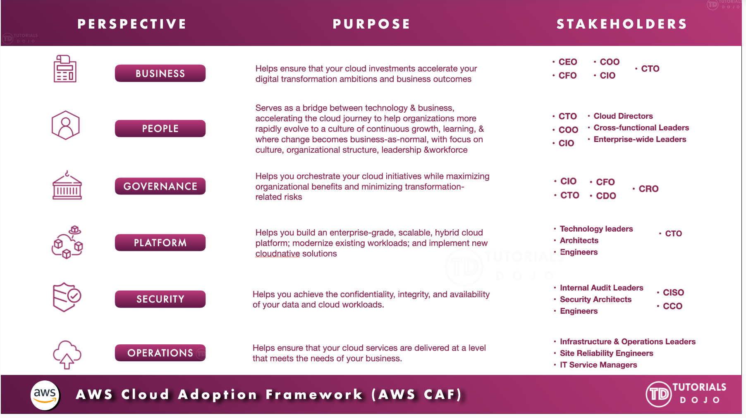
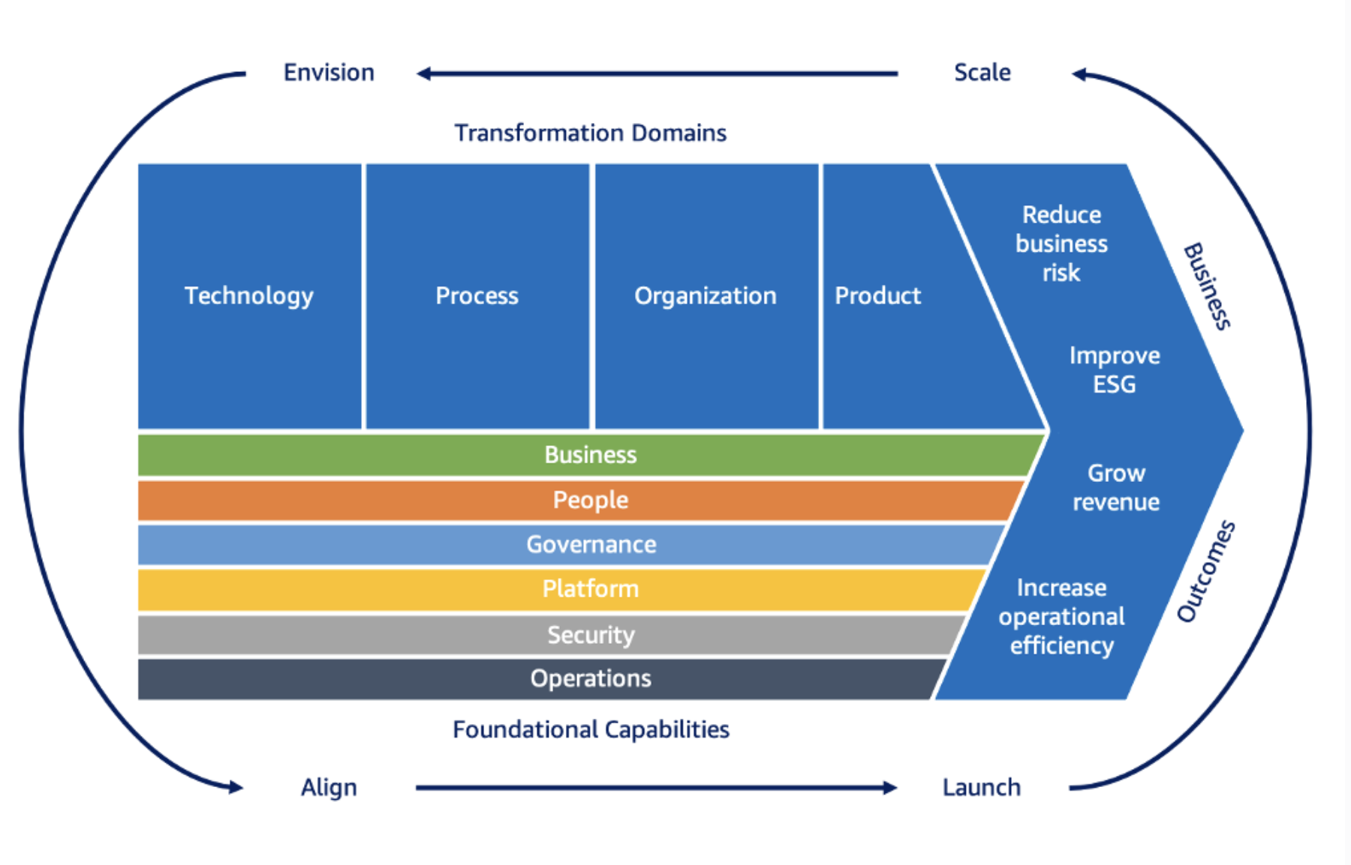

AWS CAF groups its capabilities in six perspectives:
- Business,
- People,
- Governance,
- Platform,
- Security, and
- Operations

AWS CAF – Transformation Domains
- Technology - using the cloud to migrate and modernize legacy infrastructure, applications, data and analytics platforms…
- Process - digitizing, automating, and optimizing your business operations
  - leveraging new data and analytics platforms to create actionable insights
  - using machine learning (ML) to improve your customer service experience…
- Organization - Reimagining your operating model
  - Organizing your teams around products and value streams
  - Leveraging agile methods to rapidly iterate and evolve
- Product – reimagining your business model by creating new value propositions (products & services) and revenue models

AWS CAF – Transformation Phases
- Envision – demonstrate how the Cloud will accelerate business outcomes by identifying transformation opportunities and create a foundation for your digital transformation
- Align – identify capability gaps across the 6 AWS CAF Perspectives which results in an Action Plan
- Launch – build and deliver pilot initiatives in production and demonstrate incremental business value
- Scale – expand pilot initiatives to the desired scale while realizing the desired business benefits

